**TACL commands: Tandem Advance Language:**

**FUP = File Utility Program**

FUP is a utility program used for file management. FUP is a standard software package for Non-Stop Kernel. FUP:

1. Manages disk files and processes
2. Create file, display and duplicate files.
3. Load data into files.
4. Modify file attributes.
5. Purge Files

FUP supports Enscribe disk files like Key sequenced files, Entry sequenced, Relative and Unstructured Text files (including text files).

1. TACL Command> FUP

(*this command will bring the FUP prompt i.e. “-“. You can write the commands directly on the FUP prompt*)

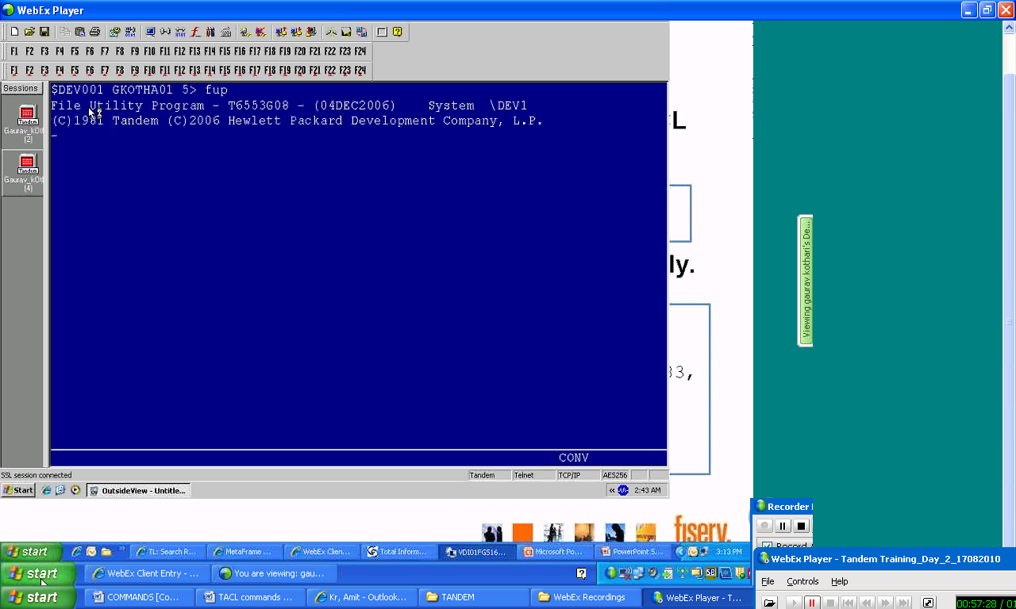

1. TACL Command> FUP $*.*.*

(*this command will show all the files available in all the volumes and sub-volumes*)

1. TACL Command> FUP info t?st

(*this command will search all the files starting with character “t” whose second character is not know but ends with “st”*)

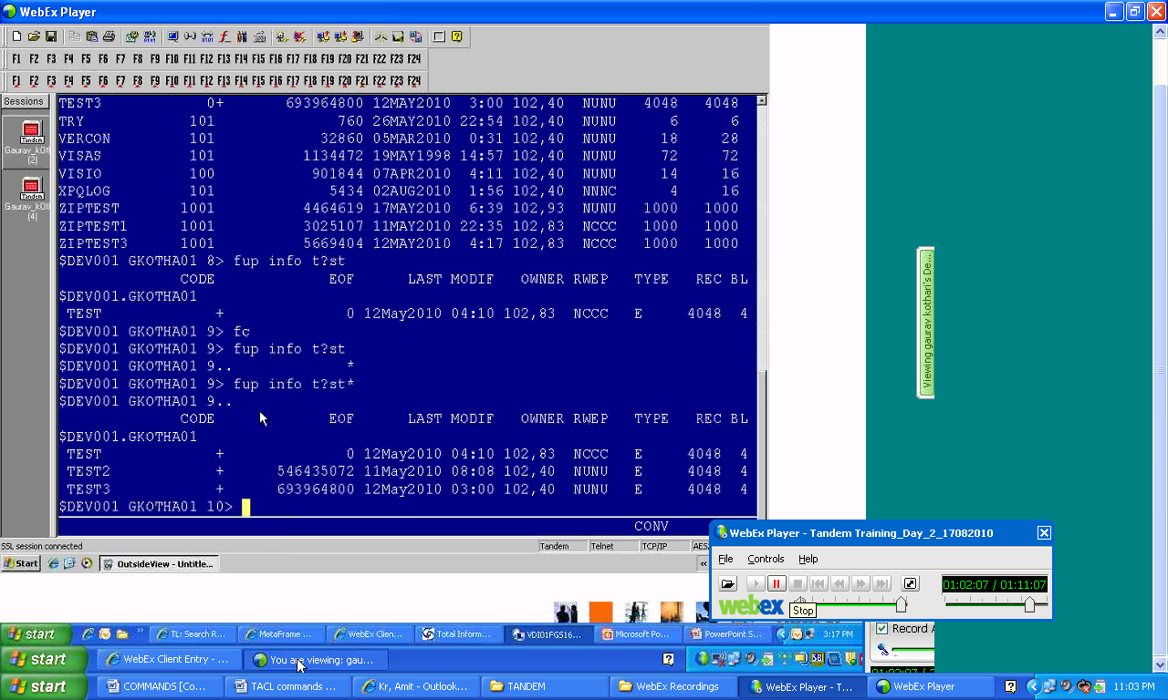

1. TACL Command> FUP info test, detail

(*this command will display you file details e.g. file type, database, format etc.*)

**1 page = 2048 Bytes,**

**1 Block = Bunch/collection of pages,**

**1 Record = Bytes required to store one record length.**

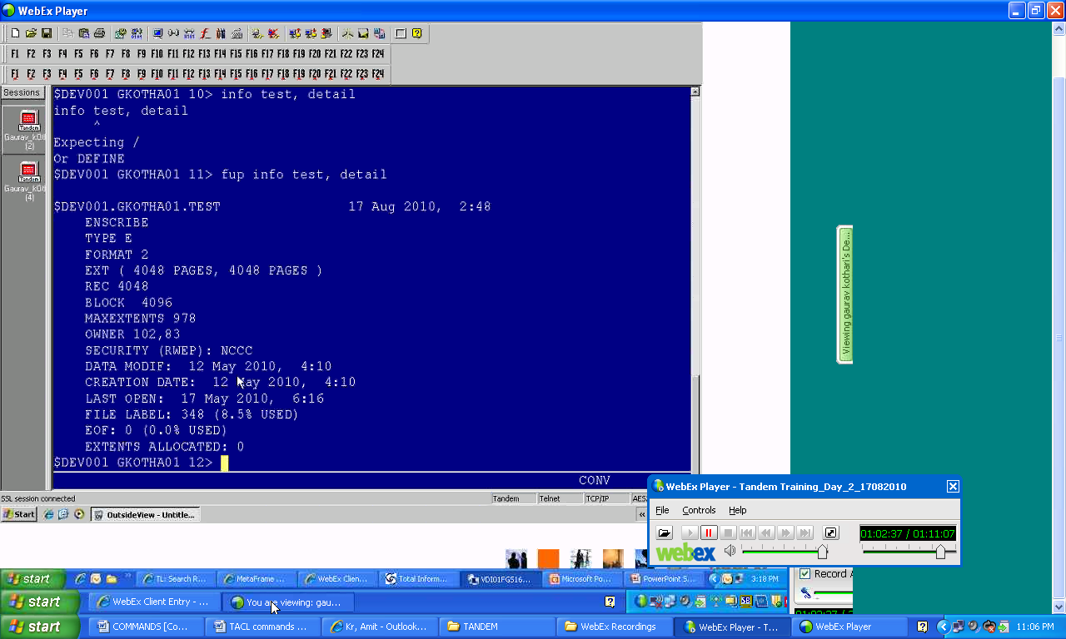

1. TACL Command> FUP DUP Test, $dasd.ancm2.*

(*this command will create a duplicate file with the same name i.e. “Test” in the volume and sub-volume “$dasd.ancm2”*)

FUP DUP = Command

Test = FileName

$dasd = Volume

Ancm2 = Sub-volume

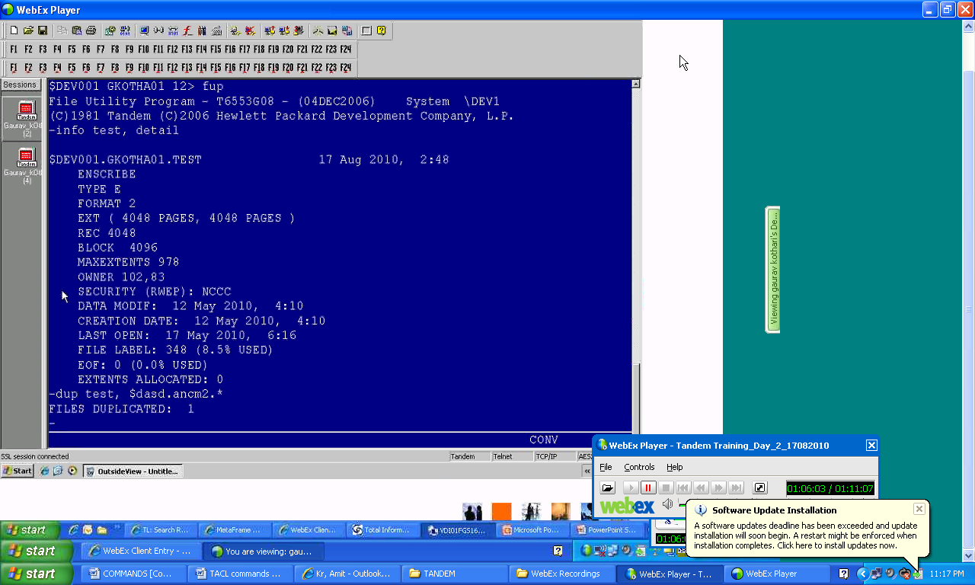

1. TACL Command> FUP DUP Test, $dasd.ancm2.* , purge

(FORCE Copy, if the file exists in the volume and sub-volume $dasd.ancm2 then it will delete it first and then will copy the file with the name “Test”)

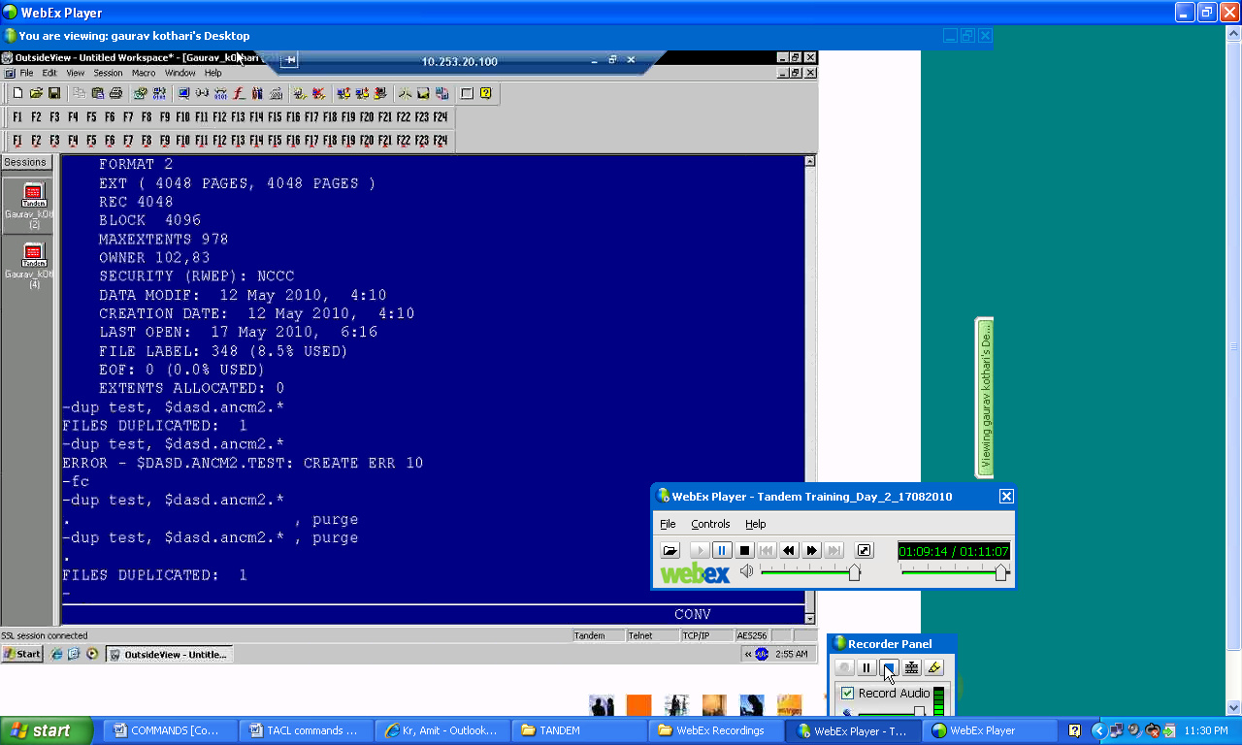

1. TACL Command> FUP DUP TEST, TESTBACKUP

(*this command will copy/backup the existing test file with another name Testbackup*)

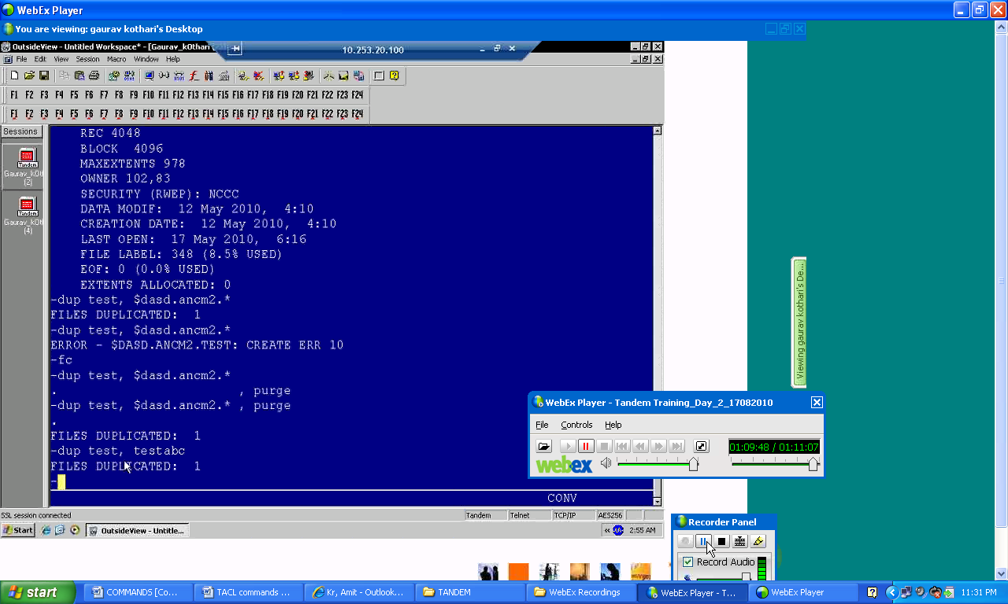

1. TACL Command>FUP Rename <oldfilename>, <newfilename>